Assignment 6 Writeup

1. Gouraud shading affects the object by changing the color at each vertex of the polygons of an object, thus changing the affect it has on the object if more vertexes (subdivisions) are involved. Because the colors that are changed are only those at the vertices, the specular highlight will only show up at the corners, seemingly jumping from vertex to vertex. The Phong shading model is more powerful in that it can affect each pixel directly, allowing the shading to look more accurate and stay accurate despite lower subdivisions. Phong shading interpolates normals on each vertex, but then goes further by finding the exact lighting on each pixel. To make this more evident, the images below show Gouraud and Phong shading, respectively, with a very low number of polygons. In the Gouraud example, the first of the two, the polygons have clear lines that allow the viewer to see the brighter center polygon and darker side polygons, particularly obvious at the peaks of the vertices. The Phong shading example, on the other hand, smoothly transitions over the ridges of the ball to deliver a cleaner, smoother light reflection that is more circular and even.

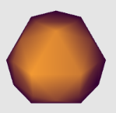 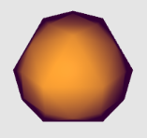

1. The Phong reflection model calculates the amount of light at each point on the shape. As such, it merely takes into account the ambient light hitting the object, and so (for example), other objects would not be reflected in the object’s surface, regardless of how shiny it is. The light’s “reflection” on the object merely is a calculation of the ambient light’s specular product on its surface. It does not include the light that may reflect off of nearby objects, or the image of reflected objects on the surface of the object in question.